Laboratory Activity 6

HTML5, CSS AND JAVASCRIPT

Objectives:

In this lab, student will be able to:
- Develop HTML5 web pages
- Familiarize with Cascading Style Sheets
- Embed the JavaScript code in HTML5 pages
I. DESCRIPTION

HTML5 – Hyper Text Markup Language Version 5
HTML5 is the 5th and newest version of HTML standard, providing new features like rich media support, interactive web applications etc.
The most interesting HTML5 elements are:
1. Semantic elements like <header>, <footer>, <article> and <section>
2. Attributes of form elements like number, date, time, calendar and range.
- Graphic elements like <svg> and <canvas>
- Multimedia elements like <audio> and <video>
There are several Application Programming Interfaces too in HTML5 like HTML Geolocation, HTML Drag and Drop, HTML Web Workers etc.
Several elements of HTML4 have been removed in HTML5 like <big>, <center>, <font>, <frame>, <frameset>, <strike> etc.
To indicate that your HTML content uses HTML5, simply add <!DOCTYPE html> on top of the html code.

Procedure to create and HTML document:
In notepad type the necessary code & save with the file name mentioned with .html or .htm extension.
Example:
<html>
<head>
<title> My First Page </title>
</head>
<body>
<h1> Hello </h1>
<h2> Welcome to Internet Technologies Lab </h2>
</body>
</html>

HTML5 Elements
HTML5 offers new elements for better document structure. The below given table gives a brief description on few HTML5 elements.
TAG | DESCRIPTION
<article> | Defines an article in a document
<dialog> | Defines a dialog box or window
<header> | Defines a header for a document or a section
<footer> | Defines a footer for a document or a section
<nav> | Defines navigation links
<time> | Defines a date/time
<output> | Defines the result of a calculation
<canvas> | Draw graphics, on the fly, via scripting(JavaScript)
<audio> | Defines sound content
<source> | Defines multiple media resources for media elements
<video> | Defines video or movie
Figure 1.1 Few HTML5 elements
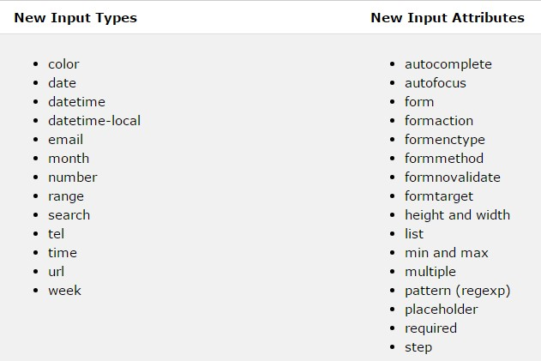
HTML5 Input types and Attributes

Figure 1.2 HTML5 input types and attributes
The above figure lists the new input types and attributes of HTML5.

HTML5 Events
On visiting a website the user perform actions like clicking on links or image, hover over things etc. These are considered to be examples for Events.
Event handlers are developed to handle these events and this can be done using a scripting language like JavaScript, VBScript etc wherein event handlers are specified as a value of event tag attribute.
The following attributes (very few) can be used to trigger any javascript or vbscript code given as value, when there is any event occurs for any HTM5 element.
Attribute | Value | Description
offline | script | Triggers when the document goes offline
onchange | script | Triggers when an element changes
onclick | script | Triggers on a mouse click
oncontextmenu | script | Triggers when a context menu is triggered
ondrag | script | Triggers when an element is dragged
onerror | script | Triggers when an error occur
onfocus | script | Triggers when the window gets focus
onformchange | script | Triggers when a form changes
onload | script | Triggers when the document loads
onmousedown | script | Triggers when a mouse button is pressed
onpause | script | Triggers when a media data is paused
onselect | script | Triggers when an element is selected
onsubmit | script | Triggers when a form is submitted
Figure 1.3 HTML5 event attributes

HTML5 Canvas
The HTML <canvas> element is used to draw graphics, on the fly, via JavaScript. The <canvas> element is only a container for graphics. The user must use JavaScript to actually draw the graphics. Canvas has several methods for drawing paths, boxes, circles, text, and adding images.
A canvas is a rectangular area on an HTML page. By default, a canvas has no border and no content. The markup looks like this:
<canvas id="myCanvas" width="200" height="100"></canvas>
Note: Always specify an Id attribute (to be referred to in a script), and a width and height attribute to define the size of the canvas. To add a border, use the style attribute.
Example: To draw a circle
<!DOCTYPE html>
<html>
<body>
<canvas id="myCanvas" width="200" height="100" style="border:1px solid #d3d3d3;"> Your browser does not support the HTML5 canvas tag.</canvas>
<script>
var c = document.getElementById("myCanvas");
var ctx = c.getContext("2d"); ctx.beginPath();
ctx.arc(95,50,40,0,2*Math.PI);
ctx.stroke(); </script>
</body>
</html>
Output
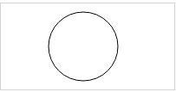

Figure 1.4

HTML5 Web Forms
The HTML <form> element defines a form that is used to collect user input. Form elements consist of various input elements like text field, check boxes, radio buttons, submit buttons etc.
<form>
</form>

Input Element
It is the most important form element and can be displayed in several ways, depending on the type attribute.
<input type = “text”> Defines a one line text input field
<input type = “radio”> Defines a radio button
<input type = “submit”> Defines a submit button

Action attribute
The action attribute defines the action to be performed when the form is submitted. Usually the form data is sent to a web page on the server when the user clicks on the submit button.
<form action = “/action_page.aspx”>
// action_page.aspx contains a server side script that handles the form data.
If the action attribute is omitted, the action is set to the current page.

Method attribute
The method attribute specifies the HTTP method (GET or POST) to be used when submitting the form data.
<form action = “/action_page.aspx” method=”get”>
The default method when submitting form data is GET. When GET is used the submitted form data will be visible in the page address field. Therefore it must not be used when sending sensitive information.
Use POST method if the form data contains sensitive or personal information. It does not display the submitted form data in the page address field. It has no size limitations and can be used to send large amounts of data.
CSS – Cascading Style Sheet
CSS is a stylesheet language used for describing the presentation of a document written in a markup language ie it describes the style of a web document including the layout, design and display variations for various displays. CSS can be applied to a web document in 3 ways.
- Inline style – Right next to the text it decorates, by using style attribute.
<h1 style = “color : blue ;”> Hello </h1>
- Internal style – At the top of the web page document, using <style> element in <head>
<head> <style> h1 { color : blue ;}
</style> </head>
- External style – in a separate file
<head>
<link rel=”stylesheet” href = “style.css”>
</head>
style.css h1 { color : blue ;} The style definitions are usually saved in an external stylesheet since changing one single file can help in redesigning the entire web document with new look and feel.

CSS syntax
A CSS rule set consists of a selector and a declaration block. The selector points to the HTML element to be styled. The declaration block contains one or more declarations separated by semicolons.

H1 { color : blue ; font-size:12px}

Selector Property Value Declaration
CSS Selectors are used to “find” or select HTML elements based on their element name, id, class, attribute etc. The element selector selects the elements based on the element name. The id selector uses the id attribute of an HTML element to select a specific element. The id of an element should be unique within a page. To select an element with a specific id, write a # character followed by the id of the element.
#para1{
text-align: center;
color:red; }
The class selector selects the elements with a specific class attribute. To select elements with a specific class, write a period (.) character, followed by the name of the class. .center { text-align: center; color:red; }
JavaScript
JavaScript is a light weight and interpreted programming language. It is a scripting language that is commonly used for the client side web development. It makes the HTML pages more dynamic and interactive.
It can be used to put dynamic text in to HTML page (Eg: document.write(“<h1>”
+ name + “</h1>”); // write variable text in to HTML page ), react to events, validate data, create cookies etc.

Syntax
It can be implemented using JavaScript statements that are placed within the <script>….</script> HTML tags in a web page. The <script> tags, containing the JavaScript code can be placed anywhere within the web page, but normally recommended to place within the <head> tags.
The <script> tag alerts the browser program to start interpreting all the text between these tags as script. The script tag have mainly two attributes language and type, specifying the scripting language used.
To select an HTML element, JavaScript very often use the document.getElementById(id) method. The word document.write is a standard JavaScript command for writing output to a page.
<script language=”javascript” type=”text/javascript”> document.getElementById("demo").innerHTML = "Hello JavaScript!"; </script>

Exercise 1:
Develop an HTML5 program to validate the credentials with appropriate internal styling with the help of CSS and JavaScript.

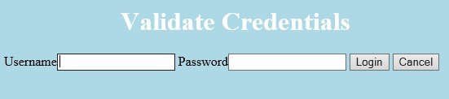
Output

Figure 1.5

Program:

Login.html
<!DOCTYPE html>
<html>
<head>
<title> Login page </title>
<style>
body {
background-color: lightblue;
}

h1 {
color: white; text-align: center;
}

p { font-family: verdana; font-size: 20px;
}
</style>
<script language="javascript">
function check(form) /*function to check userid & password*/ {
/*the following code checkes whether the entered userid and password are matching*/
if(form.userid.value == "myuserid" && form.pswrd.value == "mypswrd")
{
window.open("https://www.google.com", "_blank"); /*opens the target page while Id & password matches*/
}

else {
alert("Error Password or Username") /*displays error message*/
}
}
</script>
</head>
<body>
<h1> Validate Credentials </h1>
<form name="login">
Username<input type="text" name="userid"/>
Password<input type="password" name="pswrd"/>
<input type="button" onclick="check(this.form)" value="Login"/>
<input type="reset" value="Cancel"/>
</form>
</body>
</html>

Exercise 2:
- Write a JavaScript program to Wish a user at different hours of a day. Use appropriate dialog boxes for wishing the user. Display the dynamic clock on the webpage. Make use of CSS and HTML5 elements for creative and attractive designs. Breakdown:
  - When the page loads, JavaScript should check the current time.
  - Based on the hour, display an appropriate greeting using a dialog box, for example:
- Morning: “Good Morning!”
- Afternoon: “Good Afternoon!”
- Evening: “Good Evening!”
- Night: “Good Night!”
c) Display a live digital clock on the webpage that updates every second.
d) Use CSS to make the clock look nice (fonts, colors, borders, background).
- Update the form on your Personal Website from Lab 4, with the following:
- Retrieve all the input values using JavaScript (app.js), and print them to the browser console. Observe or maintain the HTML Boilerplate project structure. Show a screenshot of the run.
- Wish a user at different hours of a day, e.g. “Good Morning!”, etc..
- Display a live digital clock on your Personal webpage that updates every second.
let now = new Date();
let hour = now.getHours();

Homework Exercise 3: Animation
- Create an HMTL5 document to get an HTML5 element’s position on the web page with the help of CSS and JavaScript function. Example:
let box = document.getElementById("box");
let position = box.getBoundingClientRect();
console.log(position.left, position.top);
- Create an HTML5 document that displays a bouncing ball. Use HTML5 elements, CSS and JavaScript functions. Example:
let x = 0;
setInterval(() => {
x += 5;
document.getElementById("ball").style.left = x + "px";
}, 50);
3) Add some form of animation in your Personal Website. Use your creativity, but limit to only one page to keep the overall feel of the website professional.

